**Bootstrap – L2: Hands-on Assignments**

Estimated Efforts: 2 PDs

Author: [sila.sahoo@wipro.com](mailto:sila.sahoo@wipro.com)

Date: 10th Sept 2018

**TOC:**

|  |  |  |  |
| --- | --- | --- | --- |
| Topic No | Topic Name | Sub Topics | Min No of Assignments |
| 1 | Introduction to Bootstraps 4 | * Overview of Bootstrap 4 * How to use * How to download the library * Understand the directory structure and the files in library | 0 |
| 2 | Bootstrap 4 Layout | * Container Class * Fixed Container * Fluid Container * Grid System | 0 |
| 3 | Content | * Typography * Tables * Images * Figure * Code | 0 |
| 4 | Components | * Forms * Custom Forms * Input Groups * Collapse * Badges * Alerts * Modal * Media Objects * List Groups * Cards * Responsive Embed * Tooltips * Popovers * Scrollspy * Templates | 0 |
| 5 | Bootstrap Classes | * Customizing Bootstrap Classes * Bootstrap Responsive * Migration | 0 |
| **Total Min No of Assignments** | | | **1** |

**Assignment 1:**

Fitness management refers to managing an individual's fitness plan in the form of diet, workout, Yoga. You are required design Welcome web page as given in the below.

There are 5 menu options with

Home

About

Portfolio

Contact

When the user clicks on each menu option the page should scroll down to the respective section.

**Home Section**

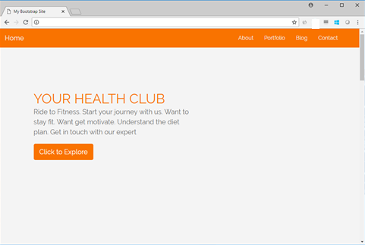

**About Section**

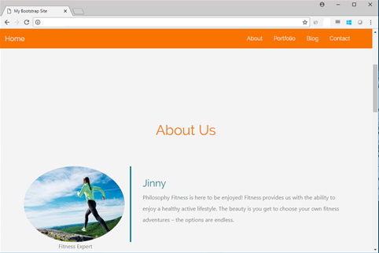

**Portfolio Section**

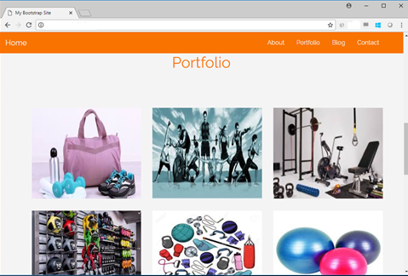

**Blog Section**

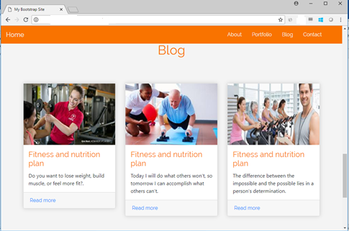

**Contact Section**

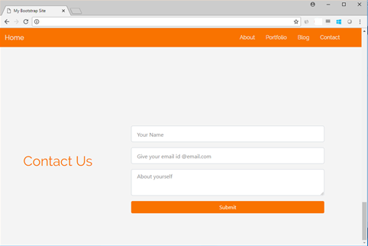

Design a web page using HTML, CSS, Bootstrap to get the above given output.

Implement all the Bootstrap features where ever applicable. Ensure the user will also view the page from any device. Ensure the mobile view is implemented.

**Apply all the Bootstrap features for the complete page design.**